Display relevant education & certification & highest position held.

Highest education  
Highest position held  
Certifications:

Angies List  
================================================================================

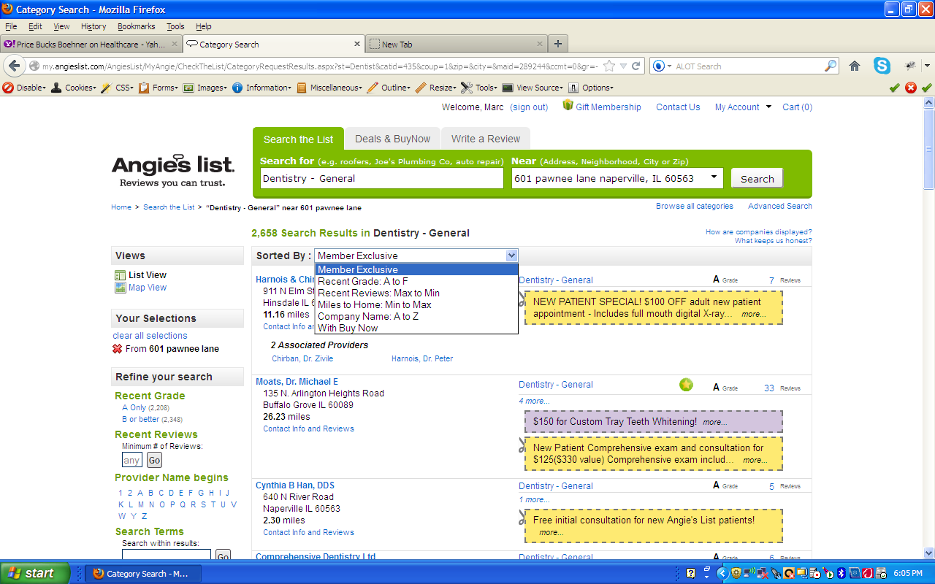

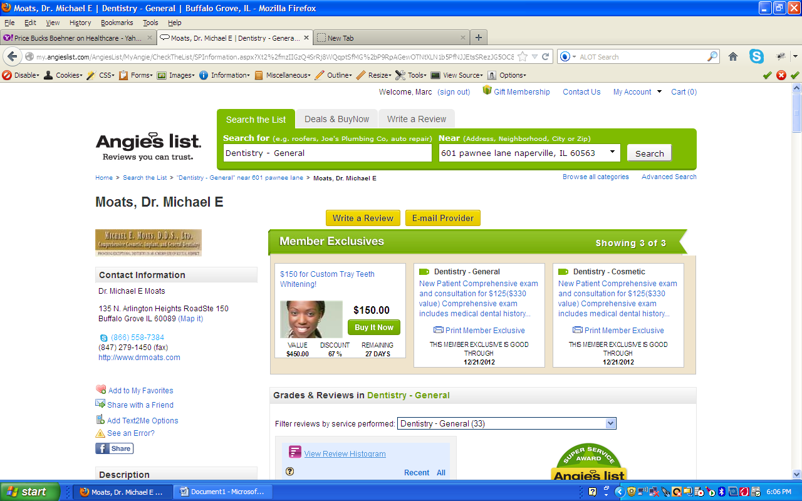

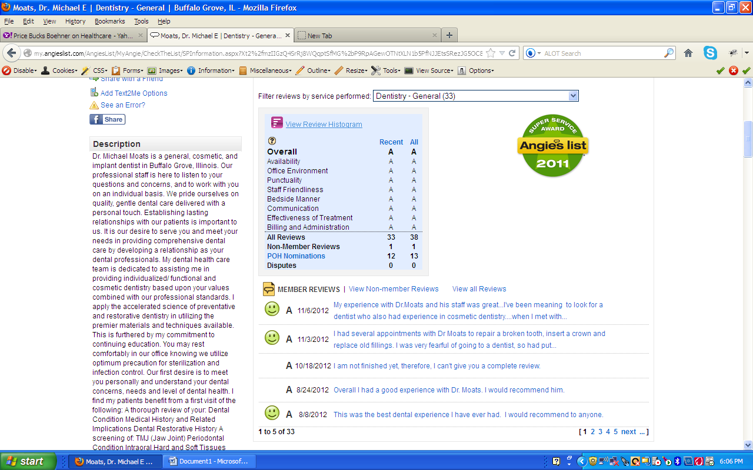

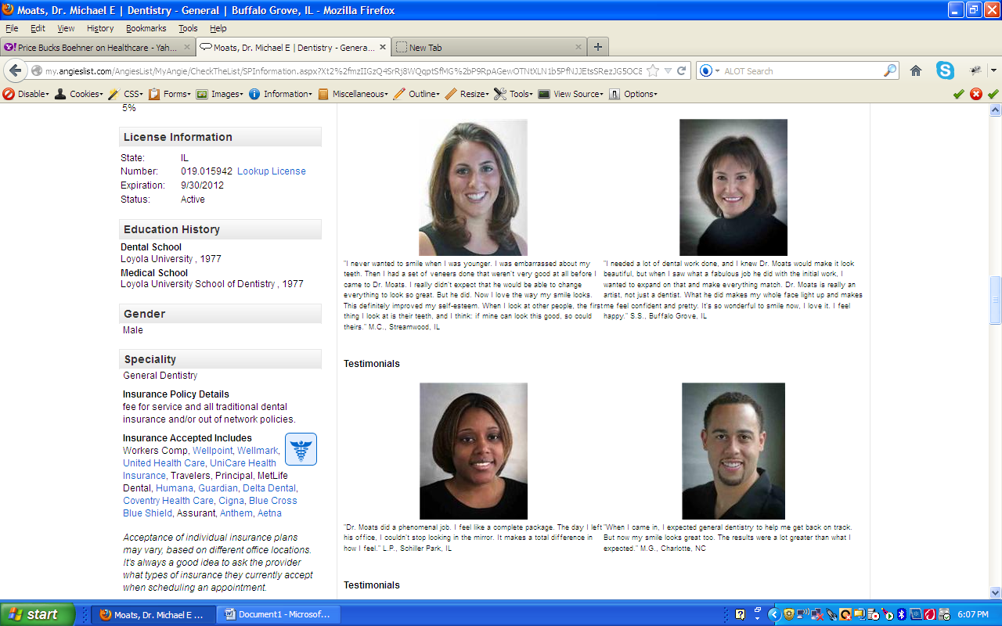

Overview  
Job History  
Certifications: Ability to upload the certifictions  
Portfolio  
Team  
About The company

Elance:

